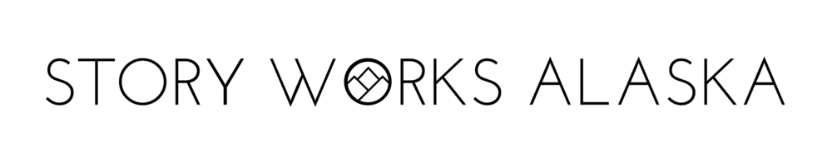
Totally Anonymous Feedback Form

A Thank You! And a Request.
Thank you for participating in this project.
Because this is such a new project, your feedback can really make a difference.
Please take a moment to tell us what worked, what didn’t, and let us know if you have any suggestions for next time.

Where and when did you participate in this Storytelling Workshop?

What worked?
What did you enjoy –if anything-- about this project?

What could have been better?
Please let us know if you have any suggestions or new ideas.

